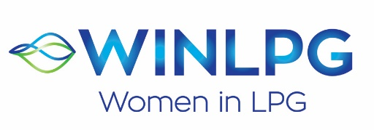

YOUNG WOMAN OF THE YEAR AWARD 2023
APPLICATION FORM

WINLPG has opened YOUNG WOMAN OF THE YEAR AWARD 2023. To enter they must be female and 35 years or younger on 31st December of the Application Year, currently employed within the LPG Industry and have a minimum of three years’ employment. They should also be someone who has shown significant contribution or commitment, or expertise or character within the business. This person will epitomise the values of WINLPG.

Please complete this form and return it to Nikki Brown, WINLPG Global Support Manager at winlpg@wlpga.org, alternatively visit www.wlpga.org and download the form. The deadline to receive completed forms is Friday 29th September 2023. Nominations can either be a person or a company nominating a candidate, or an individual nominating themselves.

Applicant’s Name

Business Title

Organisation Name and City/Country
Email

What are your current responsibilities? (MAX 200 words)

Please answer the following four questions. Please limit your replies to 200 words max per question. Please only return typed applications. Answers over 200 words will not be considered.

- What do you consider to be your/their greatest career accomplishment to date?
- What do you believe is your/their best leadership strength? Explain how this has supported you/them within your/their current role to date?
- How do you/they currently support or contribute to the development of diversity within your business?
- Explain how you/they would be a good ambassador for the WINLPG Network and the promotion of Gender Diversity within the industry?

All nominations will be reviewed by an Awards Panel.
The winner will be announced during LPG Week, in Rome, in November 2023.
Thank you!

