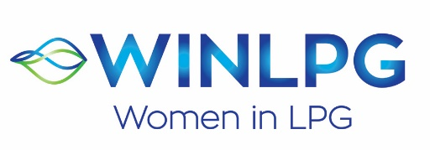

WOMAN OF THE YEAR AWARD 2023
APPLICATION FORM

WINLPG has opened WOMAN OF THE YEAR AWARD 2023. This award is for any woman operating in the LPG industry. The award is designed to recognise an individual woman who has distinguished themselves within the sector, has demonstrated leadership, has a proven record of success and influence in her community, who has shown a significant contribution to supporting diversity within the LPG industry and epitomises the values for which WINLPG stands

Please complete this form and return it to Nikki Brown, WINLPG Global Support Manager at winlpg@wlpga.org, alternatively visit www.wlpga.org and complete the online form. The deadline to receive completed forms is 29th September 2023. Nominations can either be a person or a company nominating a candidate, or an individual nominating themselves.

Applicant’s Name

Business Title

Organisation Name and City/Country
Email

What are your/their current responsibilities? (MAX 200 words)

Please answer the following four questions. Please limit your replies to 200 words max per question. Please only return typed applications. Answers over 200 words will not be considered.

- What do you consider to be your/their greatest career accomplishment to date?
- What direct impact did your/their contribution have to the business or the Industry.
- How do you/they currently support or contribute to the development of diversity within the business?
- Describe how this support or contribution has impacted the development and/or retention of your/their female colleagues.

All nominations will be reviewed by an Awards Panel.
The winner will be announced during LPG Week, in Rome, in November 2023.
Thank you!

