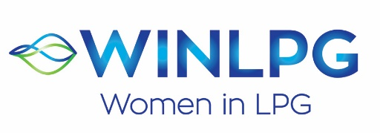

YOUNG WOMAN OF THE YEAR AWARD 2021
APPLICATION FORM

WINLPG has opened YOUNG WOMAN OF THE YEAR AWARD 2020. This award is for any woman operating in the LPG industry under the age of 35 at 1 January 2021. It is designed to recognise an individual woman who has have joined the industry with a commitment to a long-term career, who epitomises the values of WINLPG, demonstrated a level of involvement in the industry and professional growth in her career (for example sought an expansion of knowledge by pursuing additional training etc).

Please complete this form and return it to Nikki Brown, Global WINLPG Coordinator at winlpg@wlpga.org, alternatively visit www.wlpga.org and complete the online form. The deadline to receive completed forms is 30th September 2021. Nominations can either be a person or a company nominating a candidate, or an individual nominating themselves. If you need more space to write in please attach a separate note.

Applicant’s Name

Business Title

Organisation Name and City/Country
Email

Describe your current role within your company including a brief history of how you came to hold this role.

Why did you choose the LPG industry as a career choice?

What do you feel have been your key achievements in the LPG industry, and any contributions beyond your own company to the industry?

Do you currently, or have you, had a mentor? What benefits do you think this has given you?

How do you see your future career within the LPG industry?

All nominations will be considered by an Awards Panel, the winner will be selected during the WINLPG global webinar in November 2021.

Additional supporting documentation may be used to assess each application so please feel free to include any additional information but please keep this to one side of paper only (paper size European A4 or US Letter).

Thank you!

