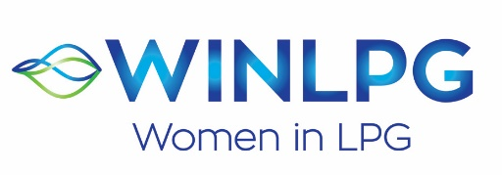

WOMAN OF THE YEAR AWARD 2021
APPLICATION FORM

WINLPG has opened WOMAN OF THE YEAR AWARD 2021. This award would be for any woman operating in the LPG industry. The award is designed to recognise an individual woman who has distinguished themselves within the sector, has demonstrated leadership, has a proven record of success and influence in her community, who epitomises the values for which WINLPG stands and who has made a particularly significant contribution to the LPG industry.

Please complete this form and return it to Nikki Brown, Global WINLPG Coordinator at winlpg@wlpga.org, alternatively visit www.wlpga.org and complete the online form. The deadline to receive completed forms is 30th September 2021. Nominations can either be a person or a company nominating a candidate, or an individual nominating themselves. If you need more space to write in please attach a separate note.

Applicant’s Name

Business Title

Organisation Name and City/Country
Email

Describe your current role within your company including a brief history of how you came to hold this role.

What do you feel have been your key achievements in the LPG industry so far?

Describe how you have excelled within the sector and/or how you made a contribution and/or any recognition you may have received to date.

Have you been involved in promoting diversity in the LPG and if so please describe?

Please describe any mentoring activity that you have taken part in.

All nominations will be considered by an Awards Panel, the winner will be selected during the WINLPG webinar in November 2021.

Additional supporting documentation may be used to assess each application so please feel free to include any additional information but please keep this to one side of paper only (paper size European A4 or US Letter).

Thank you!

